<https://www.udemy.com/course/the-complete-web-development-bootcamp/learn/lecture/37349876#overview>

Section 4 Multi Page Websites

25 Computer file paths

Use ./ instead of just /

26 What are web pages –

27 HTML Boiler plate

Starts with a doc type



Everything is in the html tag

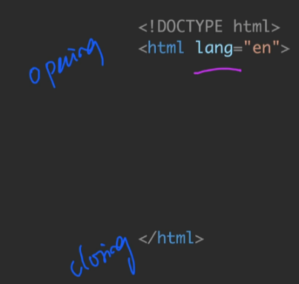

Hamburger analogy

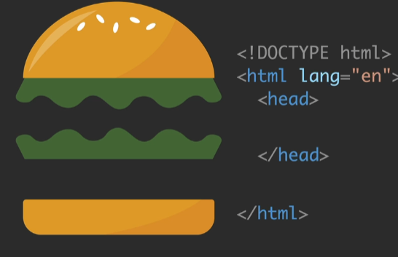

Meta tagCharset “UTF=8” encoding ensures that the charters get displayed correctly

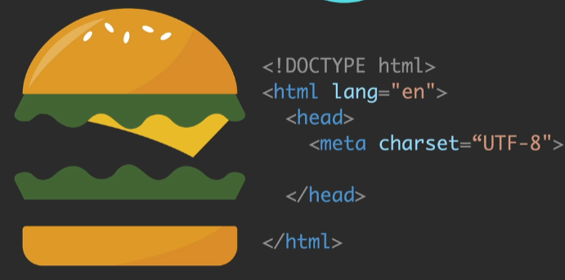

Title – it gets displayed in the browser tab bar

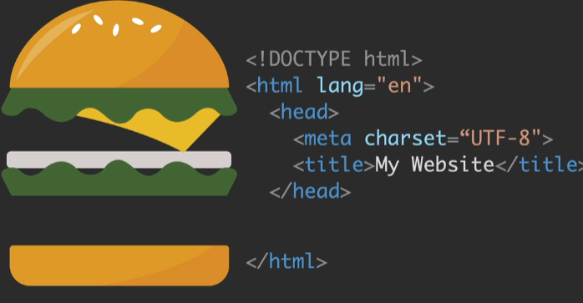

Body is all the website content = the meat of the website

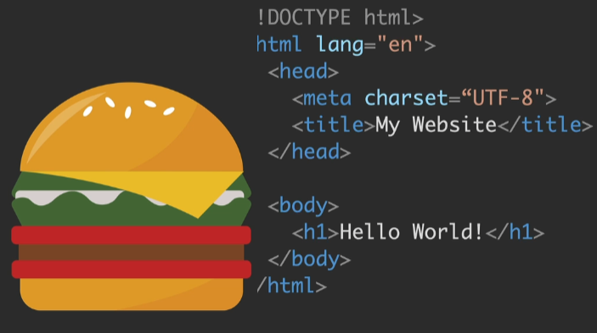

VS Code ! + entr

Hosting websites on GitHub

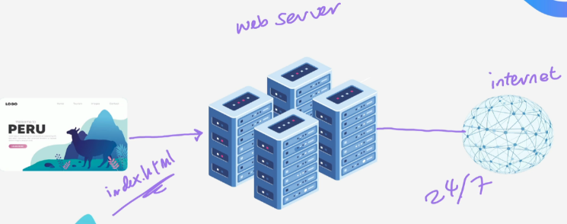

Local development – just on my computer

Put the project on the web server via web hosting

